JSTWepo Test

* Team members:

* Jacob Azevedo Jr. - jacobazevedojr@gmail.com

* Stephanie Lim - hynglim@gmail.com

* Tony Ha - tony.ha@student.csulb.edu

* William Duong - wxduong@gmail.com

**(1)** create repo for old version



**(2)**

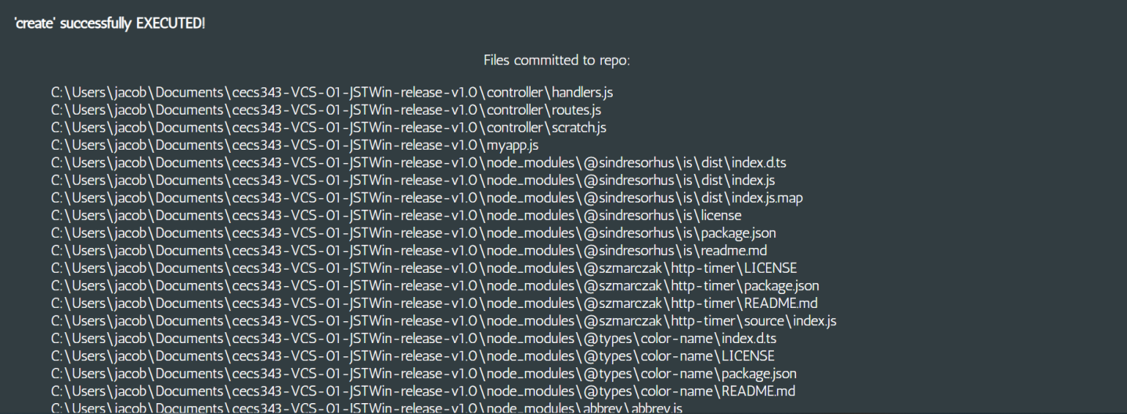

**(3)** Added new file into old project version

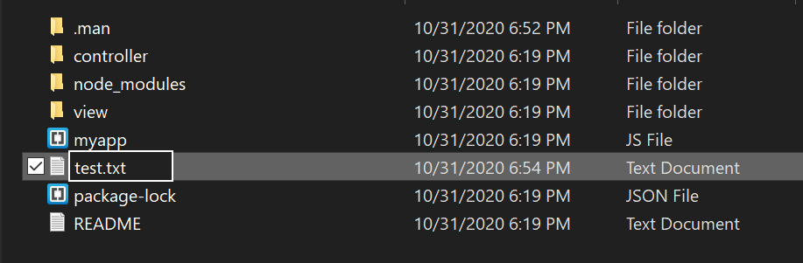

**(4)** update the repo with new changes



**(5)**

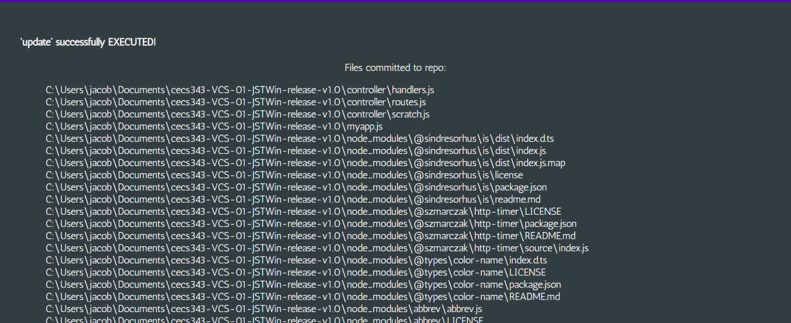

**(6)** used log command to see commits



**(7)**

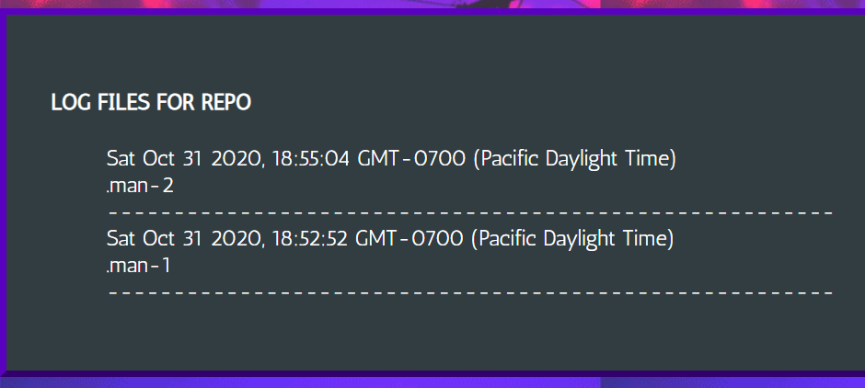

**(8)** used label command for "Alice 1" label and explicit manifest file name



**(9)**

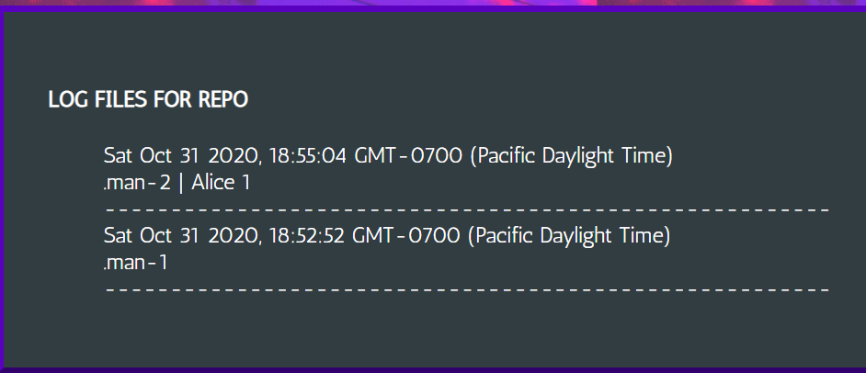

**(10)** Used another label, "Alice 1" to refer to a commit and tied "Bob #2" to it



**(11)**

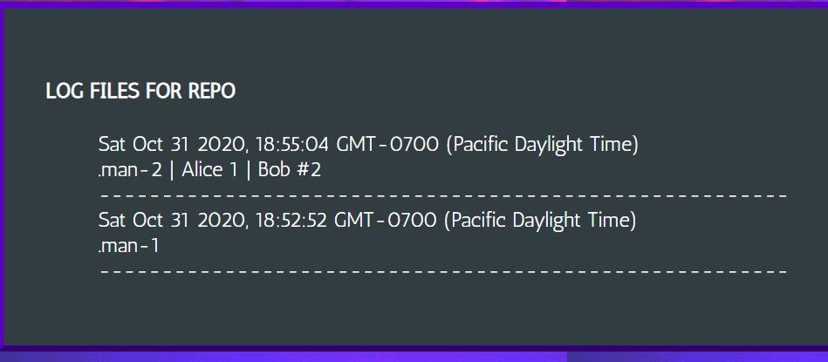

**(12)** Rebuilding "Alice 1" commit in another folder



**(13)**

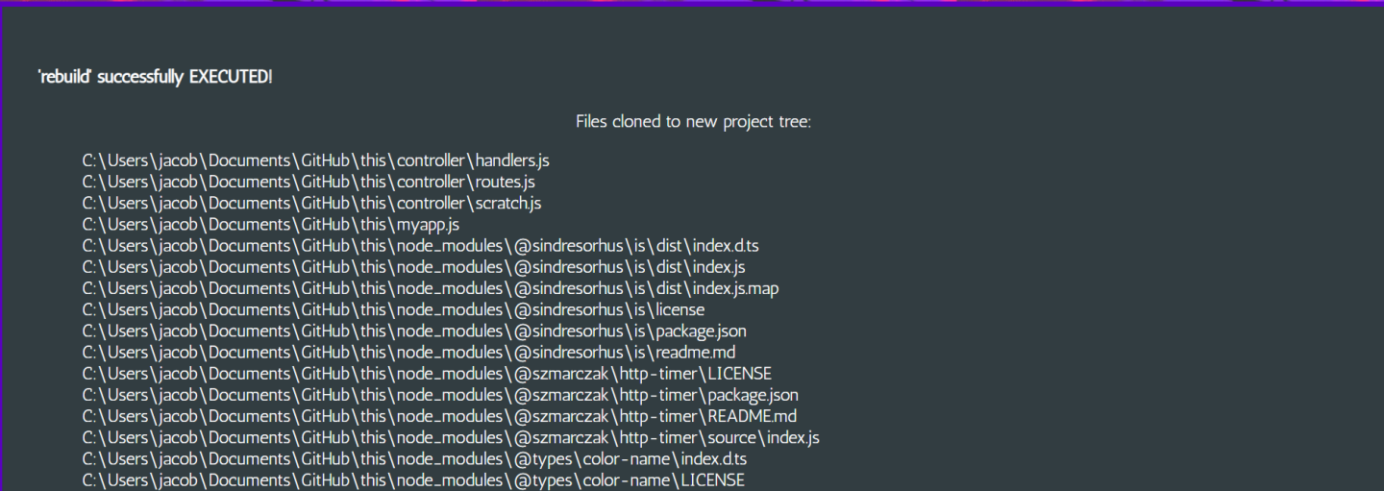

**(14)** Contents successfully rebuilt in new project folder

